Sample possible titls:

How does 2014's World on Fire compare to the 1980s?

A world on fire or echoes of the cold war?

Whither human security?

The horrors of the war in Syria, terrorist attacks, burgeoning refugee crises, the annexation of Crimea, and South China Sea disputes prompted fears about the world’s direction. But, earlier this decade, [Steven Pinker](http://stevenpinker.com/publications/better-angels-our-nature) argued violence was declining with the end of the Cold War and the success of some Peacekeeping efforts. Is that good news story obsolete?

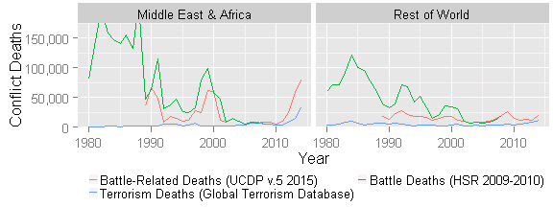

Tracking conflict deaths is difficult, as shown by the gap between [Human Security Report](http://www.hsrgroup.org/) (HSR) and [Uppsala Conflict Data Program](http://www.pcr.uu.se/research/ucdp/datasets/ucdp_battle-related_deaths_dataset/) (UCDP) data. The enormity and complexity of Syria’s ongoing civil war makes it particularly hard to measure. However, certain regional trends are clear. [Terrorism in aggregate has skyrocketed](http://economicsandpeace.org/wp-content/uploads/2015/11/Global-Terrorism-Index-2015.pdf) in countries in conflict, especially in Africa and the Middle East. Over eighty percent of the terrorism losses and ninety percent of the battlefield deaths occurred in eight countries: Iraq, Nigeria, Afghanistan, Syria, Pakistan, Somalia, Ukraine, and Yemen. On the other hand, looking back at the eighties is a stark reminder of the risks of great power rivalry and what has been overcome.

We know the 2015 data will include the ceasefire in Ukraine, direct Russian intervention in Syria, and the metastasization of ISIS terrorism beyond Iraq and Syria. The specter of Cold War violence suggests two questions: Will the absence of proxy conflict help Nigeria move towards peace despite transnational terrorist ties?  Will ISIS terrorism against Russia and NATO civilians prompt cooperation on deescalating Syria's civil war or prompt doubling down on preferred outcomes?